Non-Stop Payments

Software for ITL NV 200 Model

The Software is developed in ASP.net and the backend machine communication for the serial port is developed in the python with node.JS integration. The purpose of this software if to entertain the customer who wants to re-charge the international or local sim card. The integrations that are decided to use within the application are du-Etisalat, Etisalat, Internet payments, international top ups, gaming top ups etc.

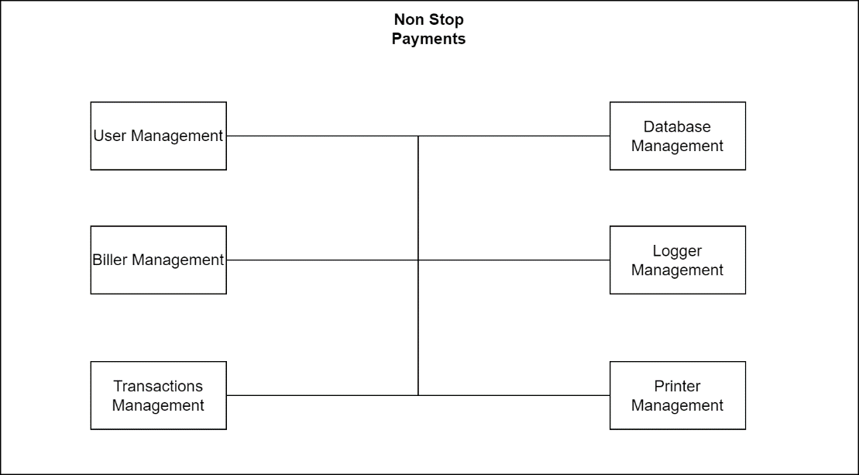

User Interface

The flowchart of UI of the application is below describing the flow of the control by the user. The frontend contains the option for the user to select the service. Then the user is asked for the mobile number against which the user is registered its account. Then the system validates the number whether the number is present in the system or not. This is verified by the API with the endpoint of search user specified with his/her contact number. Then the plans according to the terminal is loaded and the user is asked to select the plan and then the cash accepting machine is handled by the API of the backend handled in python to control the cash accepting machine. The front end is updated on the git ([Dashboard](https://github.com/ZeeshanNSP/DASHBOARD)).

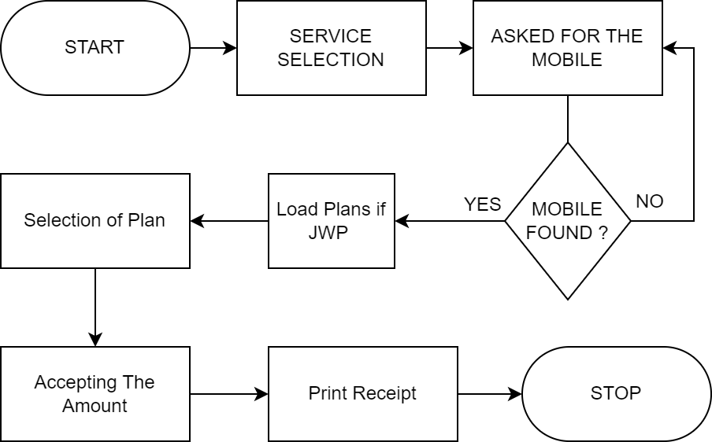

Backend

The working of the backed is developed in python flask and a server is created using it so that I provide endpoints for the data and the working. The enabling and disabled the systems biller is made using the nv9biller library that has been created to support nv9, nv10, nv100, nv200 and other are also supported. The Issues that were faced during the development of the backend were ssl certificate, port changing, com port and serial port and was resolved by using the serial library for python and the com port was direct communicated with the help of usb and win32 ui library. All the backend code has been updated on git ([nv9biller](https://github.com/ZeeshanNSP/nv9biller)).

